Expository Writing

Survey Report

Topic: The Impact of Short Videos (Tiktok, reels etc.) on Academic Performance

Submitted by:
Name: Wasif Ali Reg. No: 245187
Name: Anisa Khan Reg. No: 245215
Name: Faiqa Umar Reg. No: 245161

Submitted to:

MAM YASMEEN

Department of Computer Science
Air University - Aerospace and Aviation Campus, Kamra
Table of Contents

CHAPTER 1: INTRODUCTION 3
CHAPTER 2: Methodology 3
CHAPTER 3: FINDINGS 4
3.1. Usage Pattern 4
3.2. Purpose of Watching 4
3.3. Impact on Study Habits 5
3.4. Negative Effect on Academic Performance 5
3.5. Replacement of Study Time by Short Videos 6
3.6. Feeling Mentally Drained After Watching 6
3.7. Guilt After Excessive Video Watching 7
3.8. Benefits Reported 7
CHAPTER 4: DISCUSSION 8
4.1 Distraction and Procrastination 8
4.2 Purpose of Watching 8
4.3 Educational Benefits 8
4.4 Negative Impact 9
4.5 Role of Personal Discipline 9
CHAPTER 5: CONCLUSION 10
In summary: 10
CHAPTER 6: RECOMMENDATIONS 10
CHAPTER 5: APPENDIX 11
5.1. Survey Disclaimer 11
5.2. Survey Questionnaire 12
5.3. Survey Response Summary 12

CHAPTER 1: INTRODUCTION
In today's digital era, short video platforms like TikTok, Instagram Reels, and YouTube Shorts have significantly changed the way students consume content. These platforms provide quick entertainment, educational material, and relaxation, making them highly engaging. However, their impact on academic performance remains a debated issue.
This study investigates how short video consumption affects students' study habits, focus, and overall academic success. A survey was conducted among students to gather insights into their usage patterns and perceptions.
With the increasing popularity of platforms like TikTok, Instagram Reels, and YouTube Shorts, many students are spending a significant amount of time watching short videos. This survey was conducted to explore how these videos impact academic performance, including concentration, grades, and study habits.
A questionnaire was shared with university students, and 28 responses were recorded. The survey included questions on daily screen time, usage purpose, perceived benefits or harms, and academic habits.

CHAPTER 2: Methodology

To gain a better understanding of this issue, a structured questionnaire was designed, covering the following key areas:
- Daily Screen Time: How long students spend watching short videos.
- Impact on Study Habits: Whether short videos enhance or distract from studies.
- Learning Benefits vs. Distractions: Student perspectives on video content.
- Correlation with Academic Performance: Effects of excessive consumption on grades.
The survey was distributed via Google Forms and social media platforms, ensuring participation from a diverse group of students. The collected data was analyzed to identify trends and patterns.

CHAPTER 3: FINDINGS

3.1. Usage Pattern
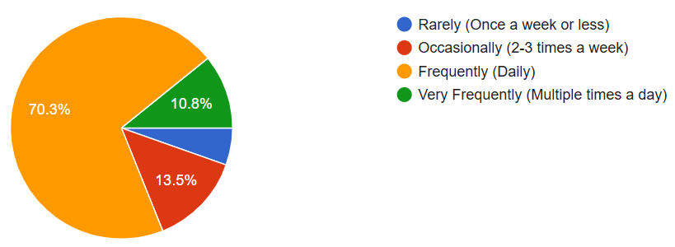
70.3% of students watch short videos daily.
Most students spend 1–2 hours daily, with a few watching more than 3 hours.

3.2. Purpose of Watching
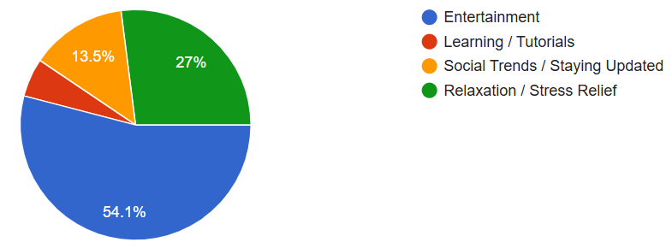
The majority (54.1%) watch videos for entertainment. Others mentioned Relaxation, passing time or learning new things.

3.3. Impact on Study Habits
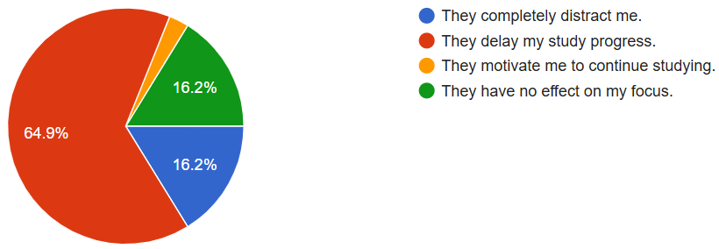

Most students (64.9%) said short videos delay their study progress, while some completely distracted by short videos and others said they balance both or use them to refresh.

3.4. Negative Effect on Academic Performance
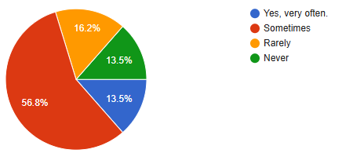
56.8% of students admitted that watching short videos sometimes negatively affects their academic performance while some thought that it always affects and some thought it Rarely affects the academic performance.

3.5. Replacement of Study Time by Short Videos
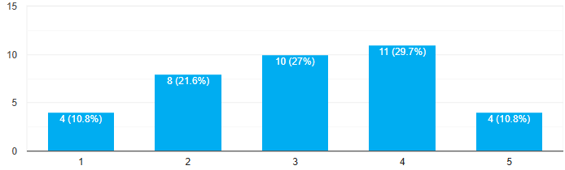
Most students (about 57%) said that short videos sometimes replace their study time, while fewer reported that it happens often or rarely.

3.6. Feeling Mentally Drained After Watching
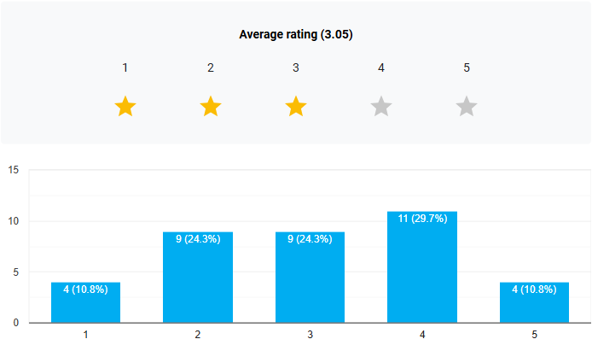
Most students said they sometimes feel mentally drained after watching short videos for too long, while fewer reported feeling this way often or rarely.

3.7. Guilt After Excessive Video Watching
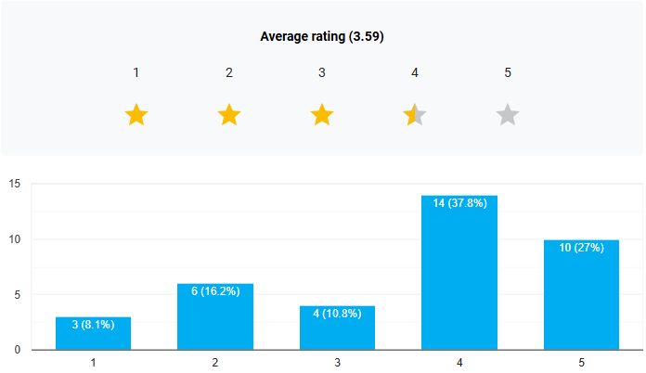
Most students reported feeling some level of guilt after wasting study time on short videos, with many selecting "sometimes" or "often."

3.8. Benefits Reported
A small group (around 30%) believed that short videos can be educational or help relieve stress.

CHAPTER 4: DISCUSSION
The survey reveals that short videos have both positive and negative effects on students' academic performance. However, the negative impacts stand out more significantly. The key findings are summarized below:

4.1 Distraction and Procrastination
A considerable number of students admitted that they consume short videos primarily for entertainment. This often leads to:
- Reduced concentration and focus
- Delayed study schedules
- Increased procrastination
- Mindless scrolling during study hours
Excessive use without regulation contributes to lower productivity and negatively affects academic outcomes.

4.2 Purpose of Watching
The primary reason for watching short videos is entertainment, as selected by the majority. Some students also cited passing time or relieving stress, while a smaller group mentioned educational content. This highlights the diverse motivations behind short video usage.

4.3 Educational Benefits
Some students (a small percentage (22.2%)) highlighted that short videos can could have positive effects, such as providing study tips, motivational content, or stress relief. Platforms like TikTok and YouTube Shorts host EdTech influencers, study tips, and concept breakdowns, which help in:
- Quick revision before exams
- Understanding difficult topics
- Discovering new learning resources
These responses suggest that when used purposefully, short videos can complement academic learning.

4.4 Negative Impact
More than half of the participants (55.6%) acknowledged that watching short videos has a negative impact on their academic performance. Common effects included:
- Distraction during study
- Procrastination and time loss
- Reduced academic focus
These negative outcomes were reported more frequently than the benefits.

4.5 Role of Personal Discipline
The impact of short videos is not universal; it varies by individual discipline. Key observations include:
- Students with good time management skills are less affected.
- Those who set limits or use short videos intentionally can benefit from motivational or educational content.
- In contrast, students who overuse these platforms tend to face difficulty maintaining study routines.

CHAPTER 5: CONCLUSION
The survey explored the impact of short videos (like TikTok, Reels, and YouTube Shorts) on students’ academic performance. The results indicate that while these platforms offer some educational content and motivational value, their entertainment-driven nature often leads to distraction and time mismanagement.
Most students reported using short videos daily, mainly for fun or to pass time. Only a few engaged with educational content. As a result, the negative effects—such as procrastination, reduced focus, and poor time management—were far more prominent than the positive ones.
However, the survey also highlights that the real impact depends on the user. Students who maintain self-discipline and regulate their screen time can avoid academic decline and even benefit slightly from the educational side of short videos.

In summary:
Short videos are not entirely harmful—but without control, they pose a real threat to academic focus. The key lies in balance and self-discipline.

CHAPTER 6: RECOMMENDATIONS
- Short videos can support learning, but overuse often harms academic focus. These recommendations aim to guide students toward smarter, more balanced usage for better academic results.
- Set Screen Time Limits
Students should regulate their daily video-watching habits using screen time trackers or app timers to prevent overuse and distractions.
- Leverage Educational Content
Institutions and educators can promote academic-focused short videos, encouraging students to engage with content that supports their studies.
- Develop Digital Discipline
Students should adopt productivity tools, study techniques, and digital well-being practices to stay focused and manage time effectively.
- Organize Awareness Sessions
Universities can hold workshops on digital wellness, time management, and content filtering to educate students about mindful media consumption.
- Encourage Parental & Peer Support
A collaborative approach involving parents and peers can reinforce healthy screen habits and accountability among students.
- Further Research
A broader study involving a larger and more diverse sample size could help uncover deeper trends and guide future strategies.
In conclusion, by adopting mindful consumption habits and balancing entertainment with education, students can enjoy the benefits of short videos without sacrificing academic performance.

CHAPTER 5: APPENDIX

5.1. Survey Disclaimer
This survey was conducted purely for academic purposes. It was open to all university students and was not limited to any specific gender. The aim was to gather general insights on how short video platforms affect academic performance regardless of gender identity.

5.2. Survey Questionnaire
Q1. Do you use short video apps like TikTok, Reels, or YouTube Shorts?
Q2. How many hours per day do you spend watching short videos?
Q3. What is your primary reason for watching short videos?
Q4. Do you follow any educational content creators on these platforms?
Q5. Have short videos ever helped you understand a topic better?
Q6. Do you think watching short videos affects your study time?
Q7. Have you ever procrastinated on assignments or study due to short videos?
Q8. On a scale of 1–5, how distracting are short videos while studying?
Q9. How often do you feel guilty about wasting time on short videos?
Q10. Any suggestions or opinions about balancing short videos with studies?

5.3. Survey Response Summary
